**Открытый урок 4аклассе.**

**Тема: «Еда и напитки».**

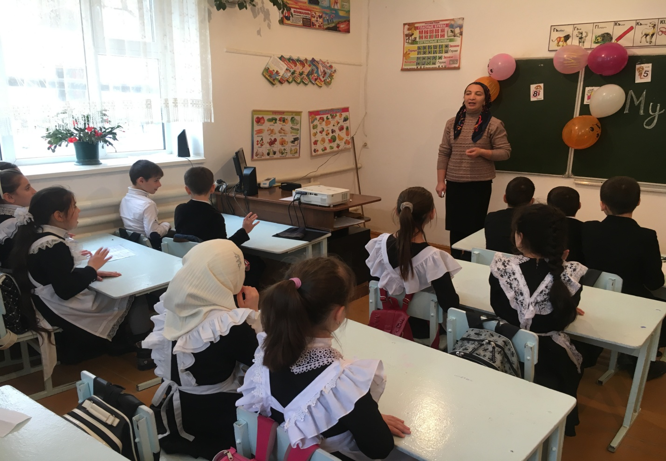

**Открытый урок 4аклассе.**

**Тема: «Еда и напитки».**

**Цели:**

1. обобщить знания учащихся по теме «Употребление глаголов во времени «Present Simple» и лексики по теме: «Еда и напитки»;
2. Совершенствовать навыки чтения, письма;
3. Развивать особенности обобщать, делать выводы, работать в группе;
4. Воспитывать у учащихся познавательный интерес, расширить кругозор.

**Ход урока.**

1. **Организационный момент.**

Good morning, dear friend.

Nice to meet you. Let me introduce myself and my friends.

Do you like English?

Do you know many English words?

Do you know how to speak about your likes and dislikes?

Let’s see who the best is.

Let’s play and see if you the words “Fruit and drinks”; if you can read the texts and do grammar tasks.

But to start with lets split into 4 groups. Everybody come up to me and take any card you want.

1. Green letters- team.

2. Yellow letter – team.

3. Blue letter – team.

4 Pink ones – team.

**Конкурсная программа.**

**Конкурс 1. «Отгадай названия команды».**

Look at the letter and guess the name of you team (каждая команда из букв составляют слово, обобщающий команды; apples, oranges, bananas, lemons. Жури учитывает время и правильность написания слов).

**Конкурс 2. «Конкурс капитанов».**

Choose the captain of you team. Stand up, captains! Introduce yourself and your friends. Follow the list of words:

1. Name

1. Age

3. Address

4. Favorite school subject

5. Hobby

6. Likes/dislikes

7. Friends

**Конкурс 3. «Цепочка слов»**

How many words about food and drinks do you know ?

Look at the word chain and find as many words as you can.

chocolateapricotoastrocknifeflouraisinssandwicheesegglassaltablematslicerealunchamushroornurmaladeggrapefruiteaspoonapkinstrawberryoghurteapotatomarangejuice

**Конкурс 4. «Чтение текста»**

It’s time for you to read. Read the text and do the tasks:

1. Where does chocolate come from?
2. Choose the best title.
3. True or fals?
4. Read the story. Where does chocolate come from?
5. America 2. Australia 3. Africa
6. Read the story about chocolate and choose the best title.

1. Chocolate factory

2. The birth of chocolate

3. It comes from Africa.

The story of chocolate starts in green jungles of Africa. They are cocoa trees there. They need a lot of sun. In November the farmers collect cocoa beans. They are as white as milk. Then the farmers dry the beans in the sun for a week, and they become brown. Ships bring the beans from Africa to Germany, France, Russia, England and other countries. In chocolate factories people make cocoa powder from the beans, add sugar, milk and nuts, and the chocolate is ready.

1. True or false.
2. Cocoa trees need a lot of sun.
3. Cocoa trees are white.
4. Cocoa beans become brown in summer.
5. The farmers dry beans for seven days.
6. There is milk, cocoa powder, sugar and nuts in a bar of chocolate.

**Конкурс 5. «Исправь ошибки»**

You know a lot of words, you can write and read. And what about grammar? Correct the mistakes.

**Correct the mistakes.**

1. My brother like fruit pie.
2. Do you eat a lot of bread?
3. They not drink a lot of spices?
4. British people likes roast turkey.
5. Does your mother uses a lot of spices
6. Do you like chocolate? – Yes, I like.
7. My friends don’t like meat. They eat only vegetables.
8. John likes fish and carrots but he doesn’t like onion and limb.

**Конкурс 6. «Конкурс чтецов».**

Who can read the poem. “Five currant buns”

best ?

Thank you everybody. In some minutes our judges will say which team is the best on. But listen to their singing. Meet Max and Ruslan with the song “let it be”.

**Подведение итогов конкурсных программы.**

Объявление победителя Вручения призов победителям и памятные наклейки всем участникам.